Maven Java Application Development

You are given the following GitHub repository link:
https://github.com/Kumbhambhargavi75/XXXXX/

- Import the project into Maven environment
Steps to import :
Open Eclipse
1.Launch Eclipse IDE (preferably Eclipse IDE for Enterprise Java Developers).
2. Clone Repository

Go to the menu:
File → Import → Git → Projects from Git (with smart import) → Next.
Choose Clone URI → Next.
Enter the GitHub repository URL (SSH or HTTPS):
  - Example (HTTPS):
  - https://github.com/username/repository.git
Select the branches you want (usually main or master) → Next.
Choose the directory where Eclipse will store the repo → Finish.

Now you can see the imported project in the eclipse under project explorer

- Questions on pom.xml (check the pom.xml correct or not and Resolve dependencies using pom.xml)
- Build the project to generate the WAR/JAR file
- Verify the generated artifact in the target/ folder
- Solve the SBQ’s ( .M2repository, junit,test,build,finalname Etc related to pom .xml))

Git and GitHub
Task: Work with Git and GitHub as follows:
Open gitbash in ECLIPSE ----Righclick on your mavenproject-->show in local terminal -->git bash

- Initialize a Git repository and add your project files
- Set global config,username and user email
- Solve the given SQB (Short Question Based) Git tasks (e.g., branch, merge, revert,stash,restore,merge conflict,gitignore,clone ) Push your Maven project to GitHub
Gitbash open in the eclipse with the path of your project.
$git init
$git add .
$git commit -m “first commit”
$git config --global user.name “your user name”
$git config --global user.email “ your email id”
Solve the given SQB’s
Push your Maven project to your GitHub
Go to your github crate a repository for mavaneproject name
Come to git bash and push
Before pushing Check the windows credentials and remove the git hub accounts/login existing if any
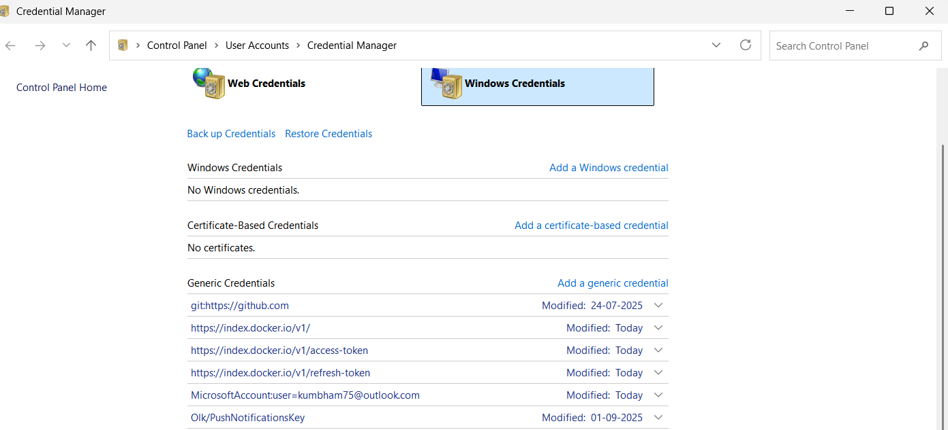
$git branch -M main
$git remote add origin1 https://github.com/Kumbhambhargavi75/LMSWEBP.git
$git push -u origin1 main
Note : if you are trying to push for the given github, access denied getting so change origin(trying to push to the owner) to origin1 or other-name and clear the github accounts in windows credentials if exist

OR push by setting URL also

git remote set-url origin https://github.com/YOURGITHUBUSERNAME/LMSWEBP.git
Now Refresh your github and check files exist or not
Docker
Note: Containerize your Maven project using Docker.(open the docker desktop and docker hub account)
EXAMPLE Tasks:
- Creation of Dockerfile and build a docker image and push it to dockerhub
- Run the image in a containerand expose to the particular port number(ex:9098)

Open gitbash in ECLIPSE ----Righclick on your mavenproject-->show in local terminal -- >terminal
OR can do in windows power shell OR gitbash
Here I opened in eclipse only ----Check the docker version exist or not
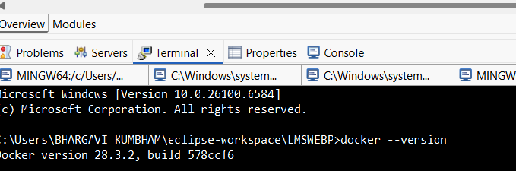
>docker ps –a
Displays the list of images running currently or previously or stopped
>docker image ls
displays the list of docker images in the local server
>docker login
login to docker hub with required credentials
SBQ’s ( pull the image Locally/Hub and run a container,check the list of containers, stop the container, start the container, run it in interactive mode,build the image ,run it on localhost by given port number)
- Dockerfile Creation
  - Ensure it copies the WAR/JAR and runs on Tomcat (or relevant base image).
> code .
Opens the vs code write the create the Dockerfile and write it
Option 1: Keep Tomcat default (8080) // check your tomcat server port, otherwise getting an error
FROM tomcat:9.0
COPY target/*.war /usr/local/tomcat/webapps/ROOT.war
EXPOSE 7089
CMD ["catalina.sh","run"]

Explanation
1.FROM tomcat:9.0
Uses the official Tomcat 9 base image.
2.COPY target/*.war /usr/local/tomcat/webapps/ROOT.war
Copies your WAR file(s) (from Maven/Gradle build) into Tomcat’s webapps folder.
When Tomcat starts, it will automatically unpack and deploy them.
By naming it ROOT.war, Tomcat deploys it as the root web application (/), so you can access it at:http://localhost:<mapped-port>/
3.EXPOSE 8080
.Important: This does not actually change Tomcat’s port.
.Tomcat by default listens on 8080, unless you edit server.xml.

- CMD ["catalina.sh","run"]
.CMD defines the default command to run when the container starts.
.catalina.sh is Tomcat’s startup script.
.The argument "run" tells it to:
Start Tomcat in the foreground (inside the container).

For java app

FROM redis:latest
CMD ["redis-server"]

- Image Building
  - Build the Docker image using docker build -t <image_name> .
Example : docker build -t lmsimage .
- docker build → tells Docker to build an image.
- -t <image_name> → tags the image with a name (so you can run it later).
- Example: -t lmsimage
- Or if pushing to Docker Hub: -t kumbhambhargavi/lmsimage:latest
- . → build context = the current directory (must contain your Dockerfile).
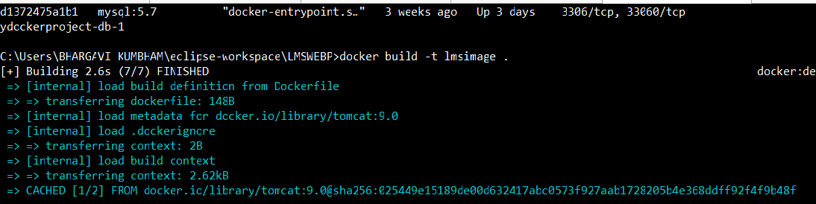
RUN THE IMAGE
$docker run -d -p 7089:8080 --name lmcontainer lmsimage
- d → run in detached mode (in background).
- -p 7089:8080 → map host port 7089 → tomcat container port 8080.
- --name lmcontainer → give the container a friendly name (lmcontainer).
- lmsimage → start from your image.
Now check http://localhost:7089/
(opens the LMSWEBP APP)
- Push to Docker Hub
- Tag and push the created image to your Docker Hub account.

Docker Hub images must be tagged as:

<dockerhub-username>/<repository-name>:<tag>

Ex: docker tag lmsimage kumbhambhargavi/lmsimage:latest

docker push kumbhambhargavi/lmsimage:latest

This will upload your image to your Docker Hub repo.

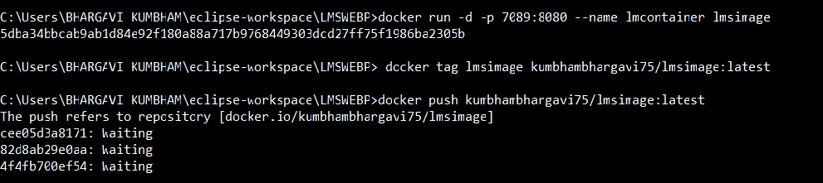

Go to https://hub.docker.com/repositories → you can see lmsimage.

PULL IMAGE OF PYTHON AN RUN IT IN INRERACTIVE MODE

A.How to run Ubuntu Image
docker run [image name]
>docker run Ubuntu
executing a docker image in the local server
docker run -it <container id / name> bash
running a ubuntu container in interactive mode…. Using bash commands to ammend
the existing image
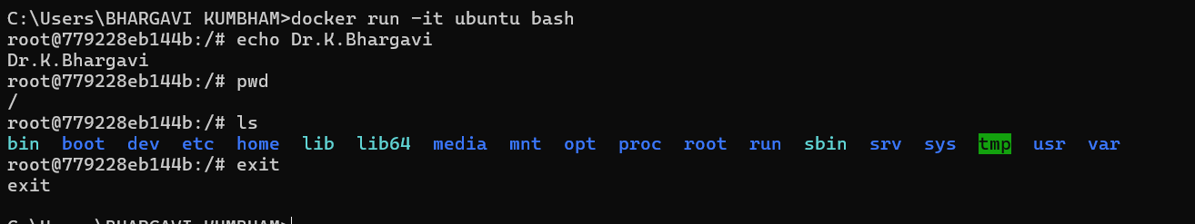
B.Pushing the images from local repository to docker hub
Tag and push the imge:
docker push <image name> push the image to the docker hub repository
C.stops running container
docker stop containerid
>docker stop 96724fc65bd8
- remove container
>docker rm 96724fc65bd8

Answer short questions related to Docker commands, image vs. container, etc

